**Experimental Design & SOP: Benthic Macrofauna Barcode Library Build Out & DNA-based AMBI Calibration**

SCCWRP POC – David Gillett – [davidg@sccwrp.org](mailto:davidg@sccwrp.org) 714-755-3249

Susie Theroux – [susannat@sccwrp.org](mailto:susannat@sccwrp.org) – 516-521-0453

STUDY DESIGN

The goal of this study is to further build out the DNA barcoding library for marine invertebrates of the Southern California Bight as well as develop the use of DNA metabarcode sequencing for calculating benthic indices. We are specifically interested in collecting, identifying, and DNA sequencing infauna taxa from along gradients of latitude (i.e., between POTWs) and depth, if possible. Our goal is to maximize the diversity among samples which will increase our likelihood of obtaining specimens for which we do not already have a DNA barcode as well as capture a number of environmental gradients to test index performance.

1. *For DNA library development:* We propose the collection of 6 samples from each of the large POTW benthic monitoring grids. Ideally, we would like 1 sample from near the outfall, 1 sample from area in the far field/control/minimum influenced area, and the remaining 4 samples from locations of convenience across the sampling grid. Sorted samples are to be preserved in 95% (non-denatured) ethanol with a 5% by volume glycerin addition. All benthic samples will be sieved on a 1-mm sieve and then placed into a relaxant (magnesium sulfate) for ½ hour. Samples will then be rinsed and placed into the ethanol-glycerin mixture. Detailed protocol below.
2. *For DNA metabarcode sequencing:* We propose the collection of sediment DNA samples from as many samples as possible. As mentioned above, capturing samples along environmental gradients would help evaluate the sensitivity and accuracy of a DNA-based benthic index. Samples are to be collected from the upper ~1cm of the Van Veen grab through 10 subsamples/scoops that are stored in a 50ml tube. Detailed protocol below.

SCCWRP staff will meet the boat at the end of the day to pick up the samples and return them to Costa Mesa.

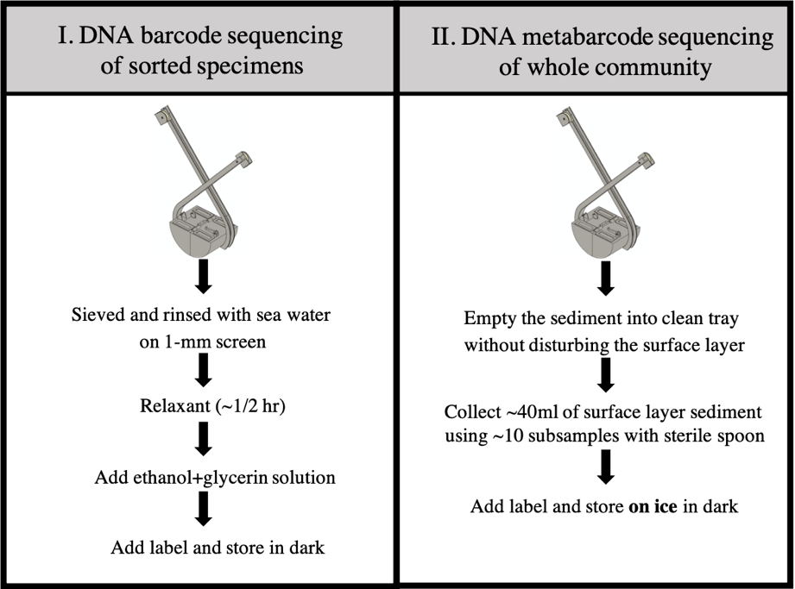

1. **BARCODING LIBRARY / GENETC AMBI STUDY SOP**

Materials needed

* Sample appropriate jars (1 per sample, plus 3 extra)
* 95% Ethanol
  + Assume 2-3L per sample
* Glycerin
* Internal label paper
* External labels

Field Operations

* Collect 1 sample from double Van-Veen
* Sieved and rinsed with sea water on 1-mm screen
* Place sieved sample in relaxant (~1/2 hr)
* Add pre-mixed ethanol+glycerin solution to sample (note time on labels)
  + Minimum target of 3:1 ratio preservative:sample volume
* Place internal and external labels
  + Station ID, date, time of preservative addition
* Store sample jar away from direct sunlight, if possible
* Transfer samples to SCCWRP staffer at the end of the day
  + Fill out CoC forms

Lab

* Store sample out of direct sunlight
* ~24hrs after first placement in alcohol, switch out w/ fresh 95% ethanol
  + Decant this ethanol into a new jar
  + Place internal label into jar and add external label
    - StationID and date of collection
    - Keep in dark, in “regular” freezer if possible
* ~48hrs after first placement in alcohol, switch out w/ fresh 95% ethanol

1. **DNA METABARCODING LIBRARY STUDY SOP**

Materials needed

* Falcon tubes (1 per sample, plus 3 extra)
* Microspatula (1 per sample, plus 3 extra)
* Latex /nitrile gloves
* Labels
* DNAway cleaning solution
* 10% bleach solution for cleaning
* MilliQ sterile water for cleaning
* Paper towels/kimwipes

Field Operations

* Wear fresh latex/nitrile gloves for each sample
* Place external labels on tube
  + Station ID, date, time of collection
* Collect 1 sample from double Van-Veen
* Empty grab into a clean tray, minimizing disturbance of the surface layer. Use sterile gloves to collect surface layer sediment (top ~1cm) with a microspatula into a pre-labelled falcon tube. Use multiple subsamples (~10 subsamples) to fill falcon tube ~40ml.
* Place falcon tube on wet ice in dark
* Transfer samples to SCCWRP staffer at the end of the day
  + Fill out CoC forms

Cleaning tray between samples

* The tray should be rinsed thoroughly to remove debris and then cleaning with 10% bleach cleaning solution or DNAway, followed by a rinse with MilliQ water to remove traces of cleaning solution. Dry with paper towels/kimwipes before next sample.

Lab

* Secure caps and store upright in -80 freezer.